Book

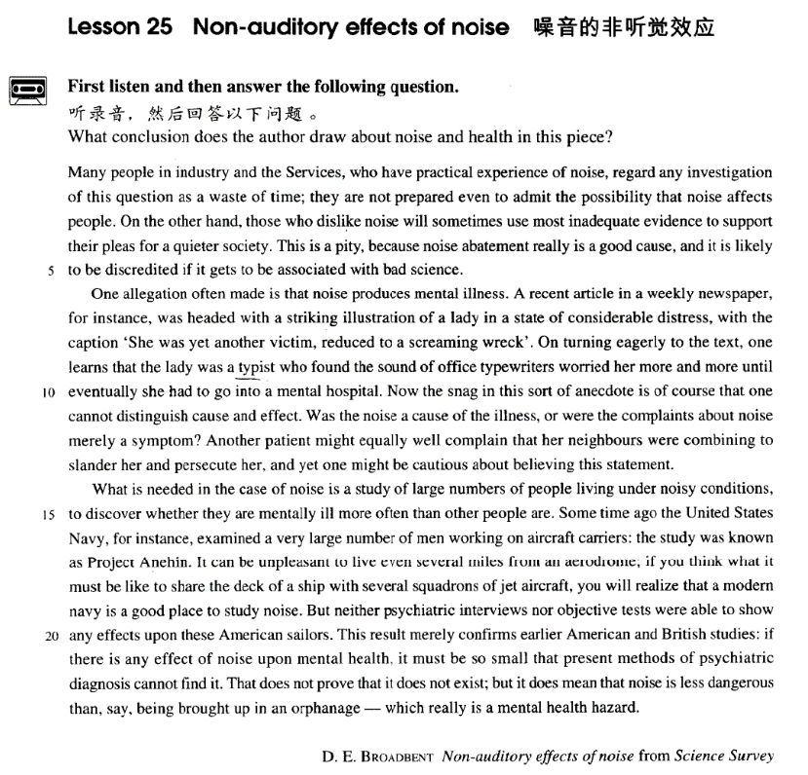

课文

Many people in industry and the Services, who have practical experience of noise, regard any investigation of this question as a waste of time; they are not prepared even to admit the possibility that noise affects people.

在工业部门工作和在军队中服役的许多人对噪声音有切身的体会，他们认为对这个问题进行调查中浪费时间，甚至不愿承认噪音可能对人有影响。

On the other hand, those who dislike noise will sometimes use most inadequate evidence to support their pleas for a quieter society.

另一方面，那些讨厌噪音的人有时会用不充分的证据来支持他们希望有一个较为安静的社会环境的要求。

This is a pity, because noise abatement really is a good cause, and it is likely to be discredited if it gets to be associated with bad science.

要求减少噪音是件好事，但是如果与拙劣的科学掺杂在一起的话，就不会被人们所信任，这是很遗憾的。

One allegation often made is that noise produces mental illness.

常见的一种指责是，噪音能引起精神病。

A recent article in a weekly newspaper, for instance, was headed with a striking illustration of a lady in a state of considerable distress, with the caption 'She was yet another victim, reduced to a screaming wreck'.

例如，最近一家周报刊登了一篇文章，文章上方有一幅引人注目的插图，是一位表情沮丧的女子，图的文字说明：“她是又一个受害者，成了只会尖叫的可怜虫。”

On turning eagerly to the text, one learns that the lady was a typist who found the sound of office typewriters worried her more and more until eventually she had to go into a mental hospital.

当人们急切地看完正文后，便知道这女子是个打字员，办公室打字机的声音使她越来越烦，最终住进了精神病医院。

Now the snag in this sort of anecdote is of course that one cannot distinguish cause and effect.

这类奇闻的疑难之处是无法区别因果关系。

Was the noise a cause of the illness, or were the complaints about noise merely a symptom?

是噪音引起了（精神）病呢，还是（精神）病的症状之一是对噪音的抱怨？

Another patient might equally well complain that her neighbours were combining to slander her and persecute her, and yet one might be cautious about believing this statement.

另有一位病人可能同样有理由抱怨说，她的邻居们正在联合起来对她进行诽谤和迫害，不过，人们不会轻信她的抱怨。

What is needed in the case of noise is a study of large numbers of people living under noisy conditions, to discover whether they are mentally ill more often than other people are.

对于噪音问题，需要对大量生活在噪音中的人进行研究，看一看他们是否比其他人更易患精神病。

Some time ago the United States Navy, for instance, examined a very large number of men working on aircraft carriers: the study was known as Project Anehin.

例如，美国海军前些时候调查了许多在航空母航上工作的人，这次调查被称之为：“安内英工程”。

It can be unpleasant to live even several miles from an aerodrome; if you think what it must be like to share the deck of a ship with several squadrons of jet aircraft, you will realize that a modern navy is a good place to study noise.

即使住在离机场几英里以外的地方，机场的噪音也会使人难受；如果你能想像出和几个中队的喷气机同在一个甲板上是什么滋味儿的话，你就会认识到现代海军是研究噪音的好地方。

But neither psychiatric interviews nor objective tests were able to show any effects upon these American sailors.

但是，不管进行精神病学的调查访问，还是进行客观的测试，都不能显示噪音对这些美国水兵有任何影响。

This result merely confirms earlier American and British studies: if there is any effect of noise upon mental health, it must be so small that present methods of psychiatric diagnosis cannot find it.

这个结果只不过证实了美国和英国早些时候的研究结论：如果噪音对精神健康有影响的话，那也一定是微乎其微，以致现代的精神病诊断方法还发现不了。

That does not prove that it does not exist; but it does mean that noise is less dangerous than, say being brought up in an orphanage -- which really is a mental health hazard.

这并不是证实不存在噪音对健康的影响。但它确实说明，噪音的危险性 -- 比如说 -- 比在孤儿院长大所受的危害要小一些，孤儿院才是真正危害精神健康的地方。

词汇讲解

### auditory

* **auditory** ['ɔ:ditəri] adj. 听觉的

**auditory** adj. **英文解释：** relating to the ability to hear 听觉的

* the **auditory** nerve

**【词根】**

“**aud**” = to hear 听

**audible**

**audience**

**audio-visual**

**audit**

**auditor**

**audition**

**audiphone**

**auditorium**

### plea

* **plea** [pli:] n. 请求

**plea** n. **英文解释：** a request that is urgent or full of emotion 请求，恳求

= **pleading**

**plea for …** 请求得到…

* The police ignored her **pleas for** help.
* On the other hand, those who dislike noise will sometimes use most inadequate evidence to support their **pleas for** a quieter society.
* In response to renewed **pleadings**, Bruce stopped.

**pleading for …** 对于…的恳求

* He was deaf to her **pleadings for** forgiveness.

**【同根词】**

**plead** v. **含义**1. to ask for something that you want very much, in a sincere and emotional way 请求，恳求

* **plead for** … 请求得到…
* Civil rights groups pleaded for government help.
* **plead with sb. (to do sth.)** 恳求某人做某事
* Moira **pleaded with** him **to** stay.

**plead** v. **含义**2. to give a particular excuse for your actions 以……为借口

* **plead** ignorance / illness / insanity … 以……为借口
* No one can **plead ignorance** of a subject any longer, for there are countless do-it-yourself publications.

### abatement

* **abatement** [ə'beɪtmənt] n. 减少，减弱

**abatement** n. **英文解释：**a reduction in sth. harmful or unpleasant 减少，减弱

* noise / pollution **abatement**
* This is a pity, because **noise abatement** really is a good cause, …

**【同根词】**

**abate** v. to become less strong 减少，减弱

* The **storm / wind / rain** has started to **abate**.

**【近义词】**表达“**减少，减弱**”：

**ebb** n. 衰退；退潮；衰落；vi. 衰退；减少；衰落；潮退

* Our enthusiasm soon began to **ebb**.

**subside** vi. 平息；减弱；沉淀；坐下

* The storm began to **subside**.
* The applause / pain gradually **subsided**.
* I wanna hold you till I die, till we both break down and cry. I wanna hold you till the fear in me **subsides**.

**wane** vi. 衰落；衰败；败落；减弱

* My enthusiasm for the project was **waning**.

### allegation

* **allegation** [7ælɪ'geɪʃən] n. 声称，断言

**allegation** n. **英文解释：**a statement that someone has done something wrong or illegal, but that has not been proved （没有依据的）声称，断言

* One **allegation** often made is that noise produces mental illness.
* an **allegation** that he had been dishonest
* Several newspapers **made allegations of** corruption in the city's police department.
* Mr. Singh has strongly **denied the allegations of** sexual harassment.

**【同根词】**

**allege** v. **英文解释：**to say that something is true or that someone has done something wrong, although it has not been proved （没有依据地）声称，断言

* It was **alleged** that the policeman had accepted bribes.
* The water is **alleged** to be polluted with mercury.
* Was the philosopher who refused to look through Galileo's telescope more culpable than those who **alleged that** the spiral nebulae observed with Lord Rosse's great telescope in the eighteen-forties were scratches left by the grinder?

### slander

* **slander** ['slɑ:ndə(r)] ['slændə(r)] v. 诽谤，中伤

**slander** v. **英文解释：**to say false things about someone in order to damage other people's good opinion of them 诽谤，中伤

* He angrily accused the investigators of **slandering** both him and his family.

**【近义词组】**表达“诽谤，中伤”：

**slur / defame / traduce / libel sb.**

* She accused the programme of **slurring** the company's name.
* The article is an attempt to **defame** an honest man.
* We have been **traduced** in the press as xenophobic bigots.
* He claimed he had **been libeled in** an article the magazine had published.

**regard sth. as a slander / slur on …** 把…看作是对…的诽谤

* Parents are often upset when their children praise the homes of their friends and **regard** it **as a slur on** their own cooking, or cleaning, or furniture, and often are foolish enough to let the adolescents see that they are annoyed.

课文讲解

# （第一段）

# Many people in industry and the Services, who have practical experience of noise, regard any investigation of this question as a waste of time; they are not prepared even to admit the possibility that noise affects people.

**语法分析：**

Many people in industry and the Services, who have practical experience of noise（who... 非限定性定语从句）, **regard** any investigation of this question **as** a waste of time; they are not prepared even to admit the possibility *that noise affects people（同位语从句）*.

知识点（1）

**service** n. **英文解释：**department of people employed by the government or a public organization 政府部门

* the Civil **Service** 政府的行政部门
* the Diplomatic **Service** 外交部门
* the National Health **Service** 国民保健部门
* This modern faith in medicines is proved by the fact that the annual drug bill of **the Health Services** is mounting to astronomical figures and shows no signs at present of ceasing to rise.

知识点（2）

**a waste of …** …的浪费

* Being unemployed is such **a waste of** your talents.
* Many believe that state aid is **a waste of** taxpayers' money.
* What **a waste of** all that good work!

知识点（3）Lesson03-41

**be prepared / ready to do sth.** 乐意去做…

* Why people **are prepared to** tolerate a four hour journey each day for the dubious privilege of living in the country is beyond me.
* Relatively few people **are prepared to** sacrifice up to a third of their holidays for the pleasure of travelling on a ship.
* …, and the doctor in charge of the department **is** only too **ready to** provide them with these requirements.

**【课文句型提炼】**

**be not prepared to admit the possibility that …** 不愿接受某事可能…

* **造句**：很多人把调查转基因食品 (GM foods) 看作是浪费时间，他们甚至都不愿意承认转基因食品可能对人有影响。
* Many people regard any investigation of GM foods as a waste of time; they are not prepared even to admit the possibility that GM foods affects people.

# On the other hand, those who dislike noise will sometimes use most inadequate evidence to support their pleas for a quieter society.

**语法分析：**

On the other hand（转折）, those who dislike noise will sometimes use most（极其） inadequate evidence *to support their pleas for a quieter society（后置定语）*. （to... 目的状语）

知识点（1）Lesson03-11、Lesson03-23

**on the one hand ... on the other (hand) ...** (used to indicate contrasting points of view, opinions, etc 用以引导出相互矛盾的观点﹑ 意见等) 一方面，另一方面

* I'd like to eat out, but **on the other hand** I should be trying to save money.
* Even really honest people are often made to feel guilty. The hardened professional smuggler, **on the other hand**, is never troubled by such feelings, even if he has five hundred gold watches hidden in his suitcase.

知识点（2）【课文仿写】

* **造句**：另一方面，那些不喜欢转基因食品的人有时会使用极其不充分的证据来支持他们对没有这种东西的日常饮食的需求。
* On the other hand, those who dislike GM foods will sometimes use most inadequate evidence to support their pleas for a diet without them.

# This is a pity, because noise abatement really is a good cause, and it is likely to be discredited if it gets to be associated with bad science.

**语法分析：**

This is a pity, because noise abatement really is a good cause（because... 原因状语从句）, and it is likely to be discredited *if it gets to be associated with bad science*（if... 条件状语从句）.

知识点（1）

**cause** n. **含义**1. 理由 [C] & [U]

* Our vicar is always raising money for one **cause** or another, but he has never managed to get enough money to have the church clock repaired.
* One would expect them to know their parts by heart and never have **cause** to falter.

**cause** n. **含义**2. 事业 [C]

* Her life was devoted to the **cause** of justice.

知识点（2）

**discredit** v. **英文解释：**to cause people to stop respecting someone or believing in an idea or person 怀疑，质疑

* Evidence of links with drug dealers has **discredited** the President.
* Some of Freud's theories have now been **discredited**.

知识点（3）

**get to do sth.**  有机会……

* We **got to** meet all the stars after the show.
* She **gets to** travel all over the place with her job.

**【辨析】**

**get to** like / know / understand … 渐渐开始……

* It'll take a while for you to **get to know** everyone.
* After a while, I **got to like** him.

知识点（4）【课文仿写】

* 造句：发展转基因食品的确是个好事业，但是如果它有机会与拙劣的科学联系起来，就容易引起人们的不信任。
* The development of GM foods really is a good cause, but it is likely to be discredited if it gets to be associated with bad science.

# （第二段）

# One allegation often made is that noise produces mental illness.

**语法分析：**

One allegation often made（后置定语） is *that noise produces mental illness**（… 表语从句）*.

知识点（1）

**produce** v. **英文解释：**to cause a particular result or effect 引起，产生，导致

* a rise in sea-level **produced** by climatic change
* As a policy, it did not **produce** the desired effect.

知识点（2）【课文仿写】

* **造句**：常见的一种指责是，转基因食品能引起潜在的风险。
* One allegation often made is that GM foods produce potential risks.

# A recent article in a weekly newspaper, for instance, was headed with a striking illustration of a lady in a state of considerable distress, with the caption 'She was yet another victim, reduced to a screaming wreck'.

**语法分析：**

A recent article in a weekly newspaper, *for instance*, was headed with a striking **illustration** of a lady in a state of considerable distress（of... 后置定语,修饰**illustration**）, with the caption *'She was yet another victim, reduced to a screaming wreck'* （caption同位语从句）（with... 后置定语,修饰**illustration**）

.

知识点（1）

**head** v. **英文解释：**if a page is headed with a particular name, title, image etc, it has it on the top

* The page **was headed** 'Expenses'.
* The information sheet **was headed** Medical Insurance.

知识点（2）

**striking** adj. **英文解释：**unusual or interesting enough to be easily noticed 醒目的， 引人注意的

* She bears a **striking** resemblance to her older sister.

知识点（3）

**illustration** n. **含义**1. a picture in a book, article etc, especially one that helps you to understand it （书或文章中的）插图

* a children's book with beautiful **illustrations**

**illustration** n. **含义**2. a story, an event or an example that clearly shows the truth about sth. 例证，例子

* The statistics **are a clear illustration of the point** I am trying to make.
* One **apt illustration of this point** involves the rapid development of Japan.
* Let me, **by way of illustration**（当做例子）**,** quote from one of her poems.

知识点（4）

**in a state of …** 处于…的状态

* He was **in a state of** permanent depression.
* Without it, nothing could ever be brought to a conclusion; everything would be **in a state of** chaos.

知识点（5）

**caption** n. **英文解释：**words printed above or below a picture in a book or newspaper or on a television screen to explain what the picture is showing 插图的文字说明

* **考研作文：**看图写作

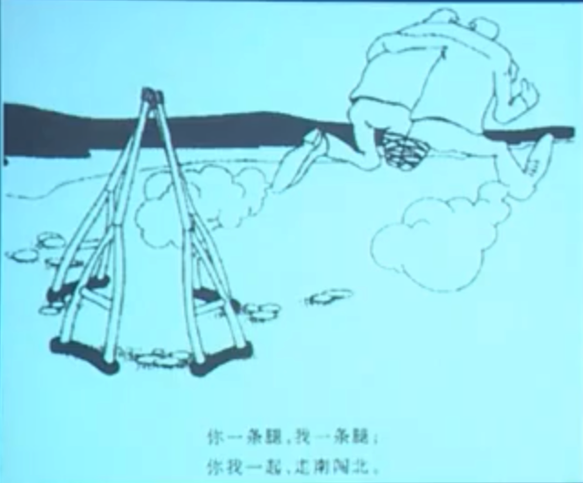

* As vividly depicted in the cartoon, two single-legged men, with their leg stumps bound together and arms tightly holding each other’s shoulders, stride ahead briskly like normal people! Their four crutches are left behind, each of them supported by the other three into the shape of a pyramid, symbolizing their owners’ cooperation. **The caption below says** ‘You have one leg left and so do I; support each other and we stride!’

知识点（6）

**yet / still (another / one more…)** 又一个、在一个

* **yet one more** question
* **still anothe**r example
* He sent **yet another** fax informing the journalist that if he did not reply soon he would be fired.
* This led to **yet another** angry argument.
* To such motives, **yet another** must be added.

知识点（7）

**reduce sb. / sth. + to sth. / to doing sth. 英文解释：**to force sb./sth. into a particular state or condition, usually a worse one 使……陷入（更糟的状态）

* a beautiful building **reduced to** rubble
* They **were reduced to** begging in the streets.
* As if this were not enough to **reduce** you **to** tears, your husband arrives, unexpectedly bringing three guests to dinner.

知识点（8）

**wreck** n. **含义**1. a vehicle or ship that has been destroyed or badly damaged

严重损毁的交通工具，残骸

* The collision reduced the car to a useless **wreck**.
* The captain of the Elkor ordered his men to salvage as much as possible from the **wreck**.

**wreck** n. **含义**2. a person who is in a bad physical or mental condition 身体或

精神严重受损伤的人，废人

* Physically, I was a total **wreck**.
* The experience left her an emotional **wreck**.
* The interview reduced him to a nervous **wreck**.

# On turning eagerly to the text, one learns that the lady was a typist who found the sound of office typewriters worried her more and more until eventually she had to go into a mental hospital.

**语法分析：**

On turning eagerly to the text（时间状语）, one learns **that** the lady was a typist *who found the sound of office typewriters worried her more and more until eventually she had to go into a mental hospital**（时间状语从句）*. *（who...定语从句）（***that**… 宾语从句）

知识点（1）

**on / upon prep.** (fml.) **英文解释：** as soon as sb. has done sth. or as soon as sth. has happened 当……时，一……就……

* All patients are examined **on** admission to the hospital.
* Couples are presented with a bottle of wine **upon** their arrival at the hotel.
* What was your reaction on seeing him?

**in** prep. **英文解释：** while doing sth. or while sth. is happening, and as a result of this在……过程中，在……期间

* **In** seeking independence, they do not sacrifice their human dignity.
* **In** the organization of industrial life the influence of the factory upon the physiological and mental state of the workers has been completely neglected.

知识点（2）

… who found the sound of office typewriters **worried** her more and more …

**地道表达**：本身含有“使”意动词：

* I didn't tell Mum and Dad ― I didn't want to make them worried. （X不地道）
* I didn't tell Mum and Dad ― I didn't want to **worry** them.
* Peter made me deeply disappointed. （X不地道）
* Peter deeply **disappointed** me.
* They made me confused by asking so many questions. . （X不地道）
* They **confused** me by asking so many questions.

知识点（4）

**mental hospital** = **psychiatric hospital** 精神病院

# Now the snag in this sort of anecdote is of course that one cannot distinguish cause and effect.

**语法分析：**

Now the snag in this sort of anecdote（后置定语） is of course that one cannot distinguish cause and effect. （that… 表语从句）

知识点（1）

**snag** n. **英文解释：**a problem or difficulty, esp. one that is small, hidden or unexpected 小的问题、困难或障碍

* There is just one small **snag**: where is the money coming from?
* Let me know if you run into any **snags**.

知识点（2）

**anecdote** n. **英文解释：**short, interesting or amusing story about a real person or event 轶事, 逸闻

* amusing **anecdotes** about his brief career as an actor

知识点（3）

**distinguish** / **differentiate** / **discriminate** v.分辨

知识点（4）

**cause and effect** 因果

* In mental illness, there is a complex relationship between **cause and effect**.

**cause-and-effect relationship** 因果关系

# Was the noise a cause of the illness, or were the complaints about noise merely a symptom?

**语法分析：**

Was the noise a cause of the illness, or were the complaints about noise merely a symptom?

知识点（1）

**cause of …** …的原因

* But I was extremely pleased with myself I had traced the **cause of** the trouble.

**【****近似词组】**注意介词搭配：x

**reason for / behind …** …的原因

* … as if mere age were a **reason for** respect.
* He explained the **reasons behind** the decision.

**motive for / behind …** …的动机、的原因…

* Economy is one powerful **motive for** camping, …
* The **motives behind** the decision remain obscure.

知识点（2）Lesson03-34、03-37

**merely a …** = **a mere …** 仅仅

* … were the complaints about noise **merely a** symptom?
* = … were the complaints about noise **a mere** symptom?
* Glancing at his map, he informed us that the next village was **a mere** twenty miles away.
* But this is not a business that can be undertaken in a day or swiftly improvised by **a mere** command of the will.

# Another patient might equally well complain that her neighbours were combining to slander her and persecute her, and yet one might be cautious about believing this statement.

**语法分析：**

Another patient might equally well complain that her neighbours were combining to slander her and persecute her（that… 宾语从句）, and yet one might be cautious about believing this statement.

知识点（1）

**may / might / could + well** … **英文解释：**used to say that sth. is likely to happen or is likely to be true （某事）可能（发生或是真的）

* What you say **may well** be true.
* You could try the drugstore, but it **might well** be closed by now.

知识点（2）

**combine** v. **英文解释：**to act together 合作，共同作用

**combine to do sth.** 共同作用…

* Many factors **combined to** cause the recession.
* Circumstances have **combined to** ruin our plans for a holiday.

**【近似词组】****【复习】**Lesson03-36

**conspire to do sth.** 合谋做某事，共同作用……

* All six men admitted **conspiring to** steal cars.
* Falling demand and high interest rates have **conspired to** produce a big drop in profits.
* Yet, in real life, circumstances do sometimes **conspire to** bring about coincidences which anyone but a nineteenth century novelist would find incredible.

知识点（3）

**yet** conj. /adv.

* Kelly was a convicted criminal, **yet**(conj.)many people admired him. It is strange, and yet it is true.
* The essay is good, **yet**(conj.) it could be improved.
* It is strange, and **yet** (adv.) it is true.
* Though he is poor, **yet** (adv.) he is satisfied with his situation.
* I agree with you, but **yet** (adv.) I cannot consent.

知识点（3）

**cautious** adj.谨慎的

* **cautious** optimism

**be cautious about (doing) sth.** 对…很谨慎

* Keller **is cautious about** making predictions for the success of the program.

# （第三段）

# What is needed in the case of noise is a study of large numbers of people living under noisy conditions, to discover whether they are mentally ill more often than other people are.

**语法分析：**

What is needed in the case of noise（主语从句） is a study *of large numbers of people living under noisy conditions（后置定语）*, to discover *whether they are mentally ill more often than other people are**（比较状语从句）*. （*whether*… 宾语从句）（to... 目的状语从句）

知识点（1）

**in the case of … 英文解释：**with reference to, or in the situation of 对于，关于；

在……情况下

* The law will apply equally to men and women except **in the case of** maternity leave.
* The amount of fruit in fruit juices must be 6% in the case of berries and 10% **in the case of** other fruits.

**【辨析】**

**in case of …** **英文解释：**if sth happens 若发生某事；假如

* **In case of** fire, ring the alarm bell.

知识点（2）

**study of …** 对于…的研究

* a **study of** Australian wild birds
* a center for the **study of** Asian languages

知识点（3）

**conditions** n. [pl.] **circumstances** 环境，情况

**under / in … conditions** 处在…环境中

* **under** existing **conditions**
* firemen having to operate **in** very difficult **conditions**

# Some time ago the United States Navy, for instance, examined a very large number of men working on aircraft carriers: the study was known as Project Anehin.

**语法分析：**

Some time ago（时间状语） the United States Navy, *for instance**（插入语）*, examined a very large number of men working on aircraft carriers（后置定语）: *the study was known as Project Anehin*.

知识点（1）

**Some time ago** 前不久

* **Some time ago**, and interesting discovery was made by archaeologists on the Aegean island of Kea.

知识点（2）

**aircraft carrier** n. a type of ship that planes can fly from and land on 航空母舰

# It can be unpleasant to live even several miles from an aerodrome; if you think what it must be like to share the deck of a ship with several squadrons of jet aircraft, you will realize that a modern navy is a good place to study noise.

**语法分析：**

it（形式主语）can be unpleasant to live even several miles *from an aerodrome*（to … 真正主语）; if you think *what it（形式主语）must be like to share the deck of a ship with several squadrons of jet aircraft（to … 真正主语）（what… 宾语从句）（*if... 条件状语从句）, you will realize that a modern navy is a good place to study noise*（that… 宾语从句）*.

知识点（1）

**aerodrome** n. **英文解释：**a place that small planes fly from 小飞机场

知识点（2）

**squadron** n. **英文解释：**a unit of one of the armed forces, especially the air force or the navy 空军或海军中队

知识点（3）

**jet aircraft** / **jet** n. **英文解释：**aircraft powered by a jet engine 喷气式飞机

# But neither psychiatric interviews nor objective tests were able to show any effects upon these American sailors.

**语法分析：**

But neither（既不） psychiatric interviews nor（也不） objective tests were able to show any effects *upon these American sailors（后置定语）*.

# This result merely confirms earlier American and British studies: if there is any effect of noise upon mental health, it must be so small that present methods of psychiatric diagnosis cannot find it.

**语法分析：**

This result merely confirms earlier American and British studies: if there is any effect *of noise upon mental health*（if... 条件状语从句）, it must be so small that present methods of psychiatric diagnosis cannot find it（that... 结果状语从句）.

知识点（1）Lesson04-01 **if让步状语从句**

**语法**：if 从句不一定是条件，也有可能是让步（**1、= even if： 即使**），要根据上下文判断

* But the first people who were like ourselves lived so long ago that even their sagas, **if** （即使）they had any, are forgotten.
* This result merely confirms earlier American and British studies: **if**（即使） there is any effect of noise upon mental health, it must be so small that present methods of psychiatric diagnosis cannot find it.
* God’s reasons, **if**（即使） He has any, are opaque to us.
* **Gre写作范文：**
* There is every likelihood that the costs of the monitoring system, such as the purchase, maintenance and updates of software, employment of extra personnel in charge of it, will offset or even outweigh additional revenue, **if**（即使）there is any.
* His descendants, **if any**（即使有）, never left the island.
* He is seldom, **if ever**（即使有，一般不修饰名词，if ever一般用于表时间的副词后，多个seldom搭配）, absent from work.

**2、= although perhaps 尽管可能…**

* Donald's essays are always interesting, **if** （尽管可能）sometimes poorly written.
* She understood his meaning, **if**（尽管可能） not his words, and took his advice. differ little

知识点（2）【课文仿写】

* 造句：即使转基因食品对于人体健康有影响，也一定是微乎其微，以至于目前的医学诊断方法无法发现。
* **If** （即使）there is any effect of GM foods upon human health, it must be so small that present methods of medical diagnosis cannot find it.

# That does not prove that it does not exist; but it does mean that noise is less dangerous than, say being brought up in an orphanage -- which really is a mental health hazard.

**语法分析：**

That does not prove that it does not exist; but it does mean that noise is less dangerous than, *say（插入语，“比方说”）*, being brought up in an orphanage ― which really is mental health hazard（定语从句）.

知识点（1）

**say** 插入语，“比方说”

* No matter where you live, you would find it difficult not to laugh at, **say**, Charlie Chaplin's early films.
* The Americans would happily reach one accord on standards for medical devices and them hammer out different pacts covering, **say**, electronic goods and drug manufacturing.

知识点（2）Lesson03-29

**bring up sb.** 把某人抚养成人

* Whether we find a joke funny or not largely depends on where we have **been brought up**.
* He did not marry again and I **was brought up** without a woman's care; but I lacked for nothing, for he was both father and mother to me.

**【辨析】【复习】**Lesson03-23

**be brought up to do sth.** 从小就……

* The sad truth is that most of us have **been brought up to** eat certain foods and we stick to them all our lives.
* We have **been brought up to** fear insects.

知识点（3）

**hazard** 危险、隐患

* a health / safety / fire / traffic **hazard** …隐患

**be / present / pose / constitute a hazard to …** 对…构成隐患

* The busy traffic entrance **is / presents / poses / constitutes a hazard to** pedestrians.
* Our knowledge of the oceans a hundred years ago was confined to the two-dimensional shape of the sea surface and the **hazards** of navigation **presented** by the irregularities in depth of the shallow water close to the land.